
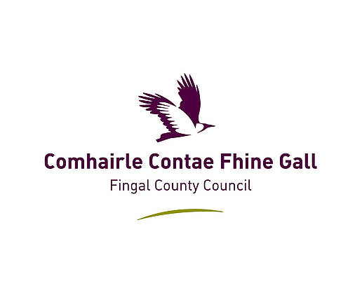
Flavours
of Fingal 2026

Children’s Activities in the Farmers Field

- Children’s Treasure Hunt in the Horticultural Marquee
- Plant some seeds, bring them home & watch them grow
- Creative Competitions for children under 9 & under 15
- Great cash prizes for all competition winners

Children Competitions under 9 years (on day of show)
801 Miniature Garden in a container, or biscuit tin. Max size 35cm x 35cm
802 Model or item made from any or all of the following: fruit, vegetables, flowers, foliage.
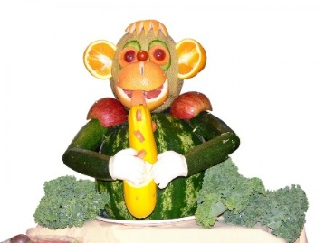
803 Best dressed hard-boiled egg.
804 A vase of wildflowers.
805 Display of 6 named leaves or flowers, A4 size.
806 Painting or drawing of a flower, A4 size.
807 Any item made from recycled materials.
808 Handmade Greeting Card, A5 Size.

Children Competitions under 15 years (on day of show)
810 Miniature Garden in a container, or biscuit tin. Maximum size 35cm x 35cm approx.
811 Model or item made from any or all of the following: fruit, vegetables, flowers, foliage.
812 Homemade Traybakes, 3 on a plate.
813 Painting or drawing of a flower, A4 size.
814 Any vegetable that you have grown yourself.
815 Handcrafts, any item.
816 A garden design on A4 paper…be creative.
817 Any photo that you have taken yourself.
818 Handmade Greeting Card, A5 Size

To enter Competitions Email: info@fingalhorticulturalsociety.com
or Phone: 0863901105

Plus, see all the farm animals Cows, Sheep, Chickens, Geese, Ducks, the Sheep Dog Trials and new for 2026 the amazing Pigmy Goats.

